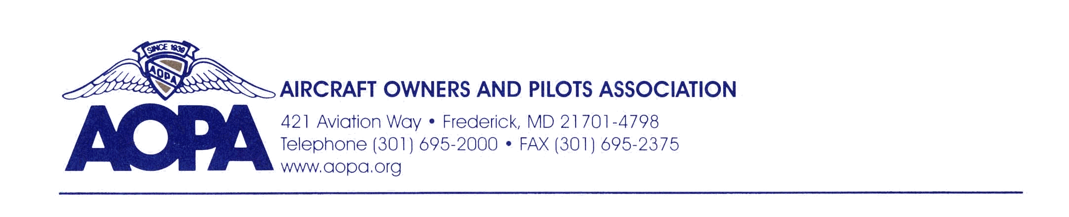
Testimony of Bryan Budds from the Aircraft Owners and Pilots Association (AOPA) in Opposition to Senate Bills 415 and 416

Before the Michigan House Transportation and Infrastructure Committee

March 18, 2014

Chairman Schmidt and Committee Members,

Thank you for accepting this testimony on behalf of the more than 10,400 AOPA members in Michigan. As the State continues its comprehensive examination of the overall transportation funding issue, AOPA members are pleased to see the Legislature’s inclusion of aviation infrastructure and fuel tax competitiveness in that discussion.

As you are all well aware, aviation funding in Michigan has been at a crossroads for quite some time where aviation fuel tax rates – the combined 6% sales tax and $0.03/gallon excise tax – remain among the highest in the country while state investment in its aviation infrastructure remains limited due to an unpredictable and unsustainable funding stream. This predicament has incentivized both the State’s pilots and transient pilots to forgo purchasing fuel in Michigan, in favor of other more competitively taxed states – limiting not only state revenue generation for airport improvements, but also the business activity at the more than 115 fixed base operators in Michigan.

While Senate Bills 415 and 416 may partially address the issue of competiveness, the bills present several new problems for the more than 14,000 Michigan resident pilots, including myself, in additional to the countless numbers of transient pilots of piston powered aircraft operating in Michigan today.

- First, Senate Bills 415 and 416 fail to address the need for a dedicated, sustainable aviation infrastructure funding mechanism. Without a dedicated revenue stream, the quality of Michigan’s critical aviation infrastructure is placed in jeopardy. Further, hundreds of millions of Federal Aviation Administration Airport Improvement Program (AIP) dollars hang in the balance should the State Aeronautics Fund not have the available balance needed to provide the state matching portion of any AIP grants. If Michigan is unable to accept grants those AIP dollars are made available to any neighboring state able to provide the local match.

- Second, Senate Bills 415 and 416 fail to completely address the competitiveness issue for users of aviation gasoline. As you may know, aircraft generally use one of two types of fuel depending on the type of engine – 100 octane, low-lead fuel known as Avgas or turbine fuel known as Jet A. While the bills reduce the effective tax rate for jet fuel, users of avgas, which generally costs more than $1.00 per gallon more than jet fuel, are left with the current 4th highest in the national aviation fuel tax rate. This further limits the economic opportunity for Michigan businesses that rely on avgas sales for their business’s success and driving general aviation’s economic impact exceeding $4.1 billion annually across the border to neighboring states.

AOPA appreciates the intent of Senate Bills 415 and 416. However, we suggest that minor modifications to the bills can have numerous positive impacts for the State’s Aviation System, the pilots and passengers that use the system, the businesses that rely on a strong general aviation industry, and the State through increased aviation activity and in turn increased ancillary revenue collection. AOPA would be happy to work with the Committee to achieve an equitable solution.

Thank you for this opportunity to testify and I welcome any questions you may have.

